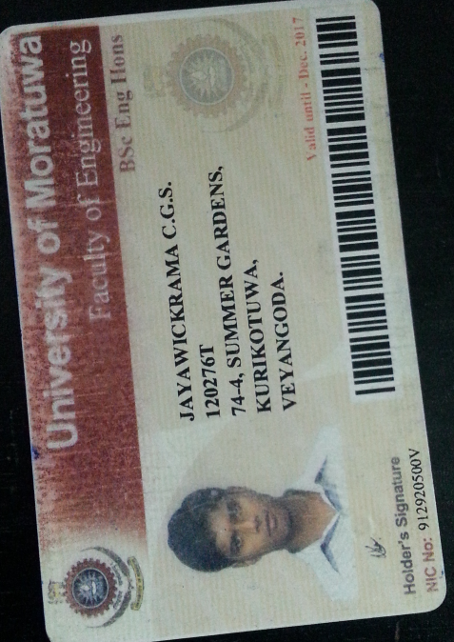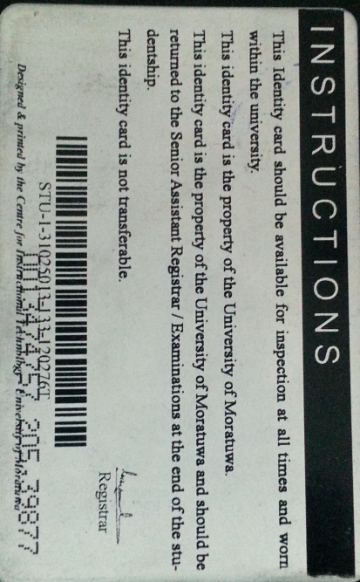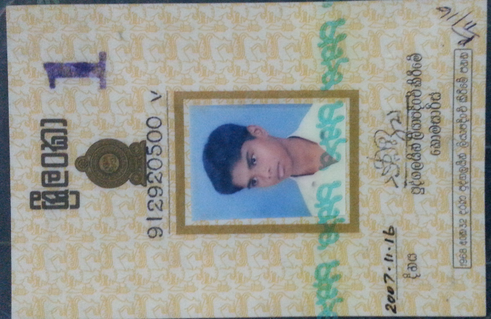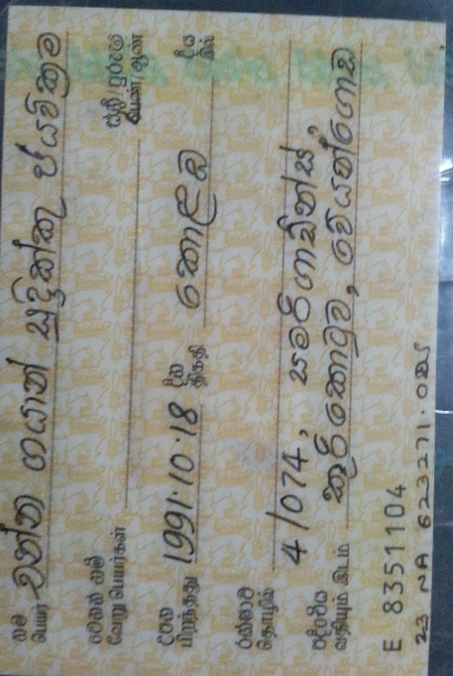



8994032300714382373

Name : Channa Gayan Sudrikku Jayawikrama.

NIC : 912920500

ADDRESS : 74-4, Summer Garden, Kurukotuwa, Veyangoda.

Contact NO : 0710 903 403

PACKAGE : 9GB